Probability- Questions
Key Stage 3: 2003 Paper 1 Level 3_5
1.
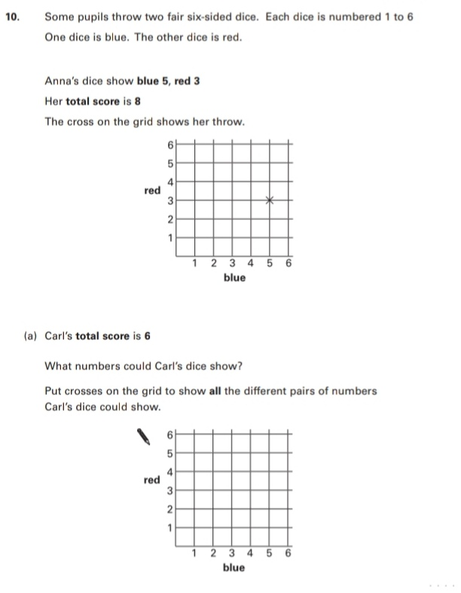
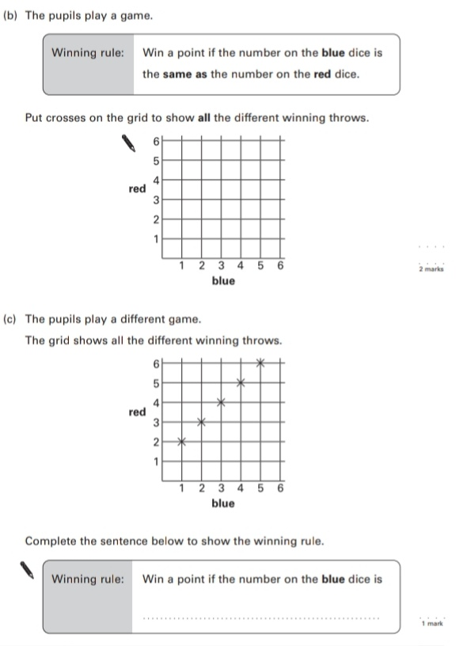

Key Stage 3: Paper 2 Level 3_5
2.
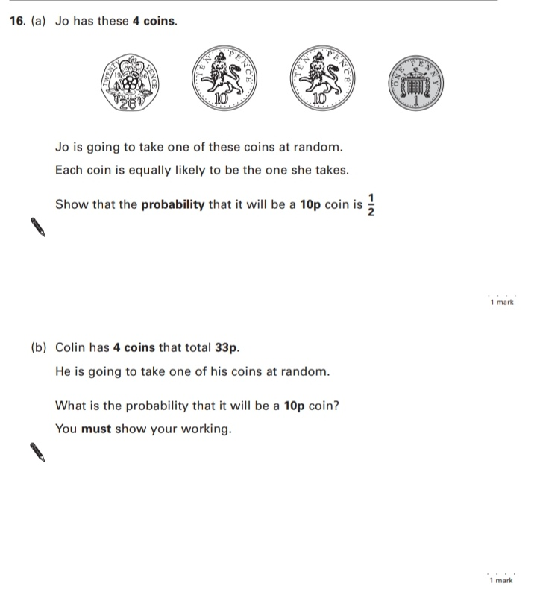
Key Stage 3: 2003 Paper 1 Level 4_6
3.
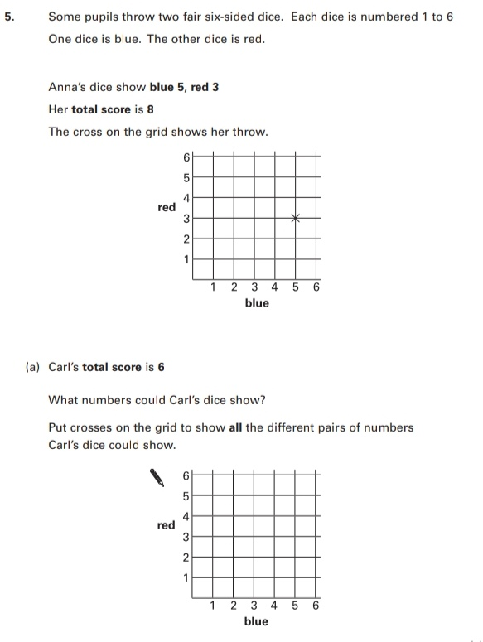
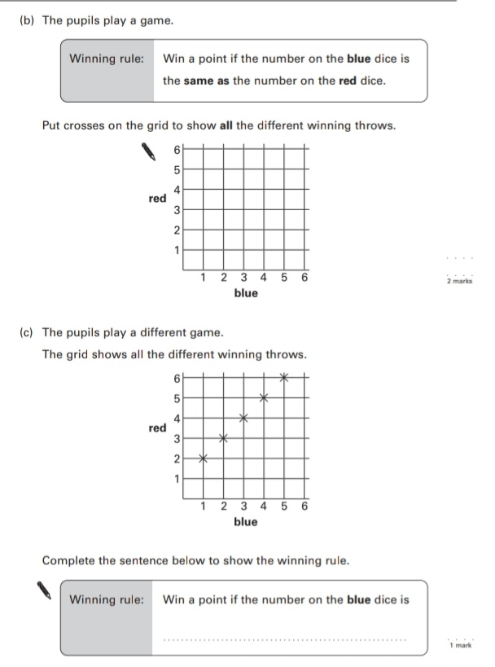
Key Stage 3: Paper 2 Level 4-6
4.
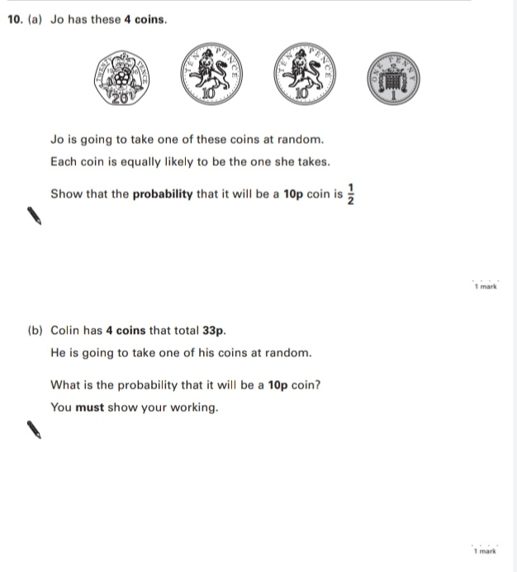
Key Stage 3: 2004 Paper 1 Level 3-5
5.
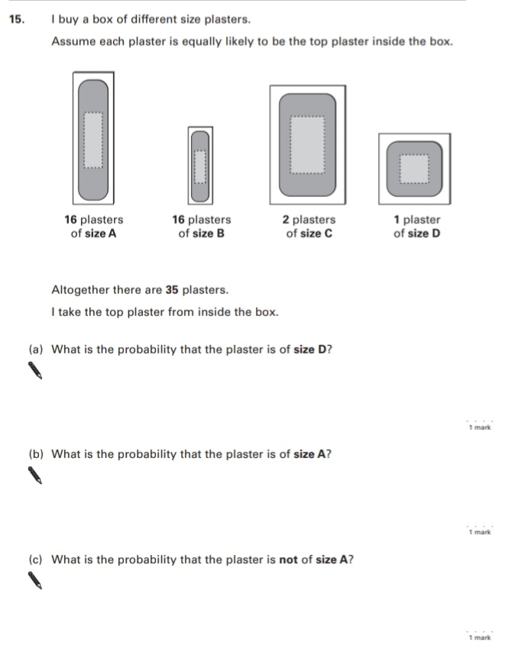
Key Stage 3: 2004 Paper 1 Level 4-6
6.
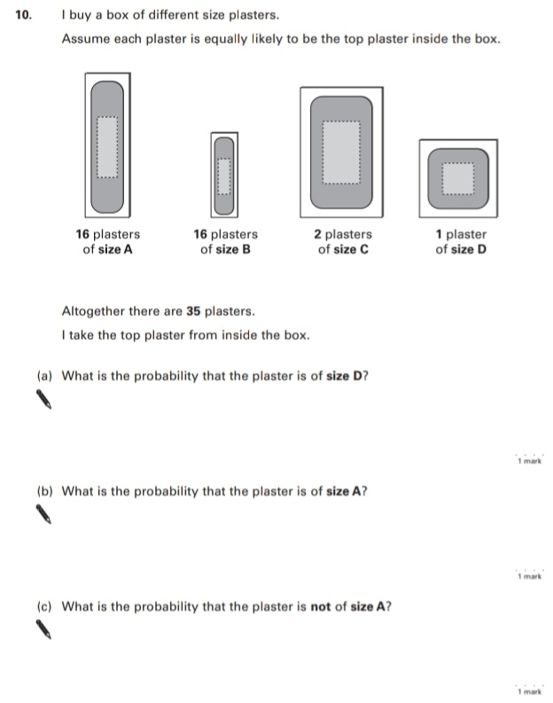
Key Stage 3: 2005 Paper 2 Level 3-5
7.
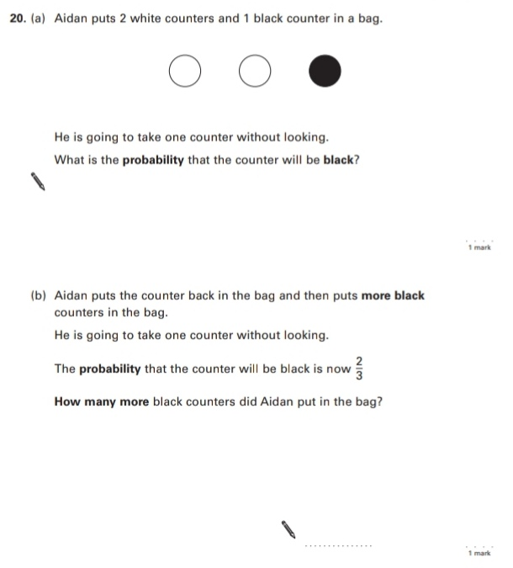
Key Stage 3: 2005 Paper 2 Level 4-6
8.
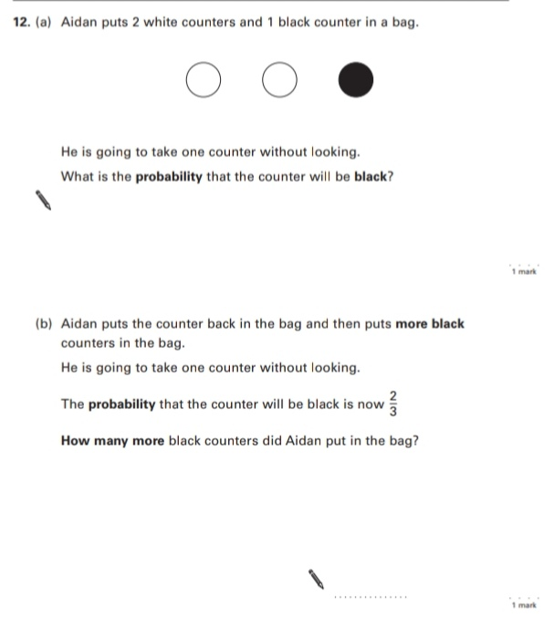
9.
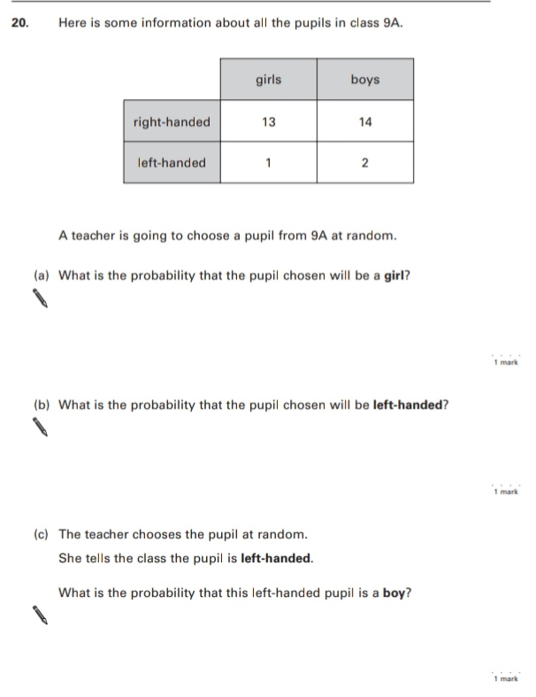
10.
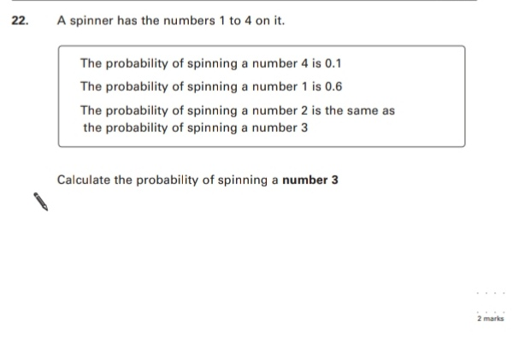
Key Stage 3: 2006 Paper 2 Level 3-5
11.
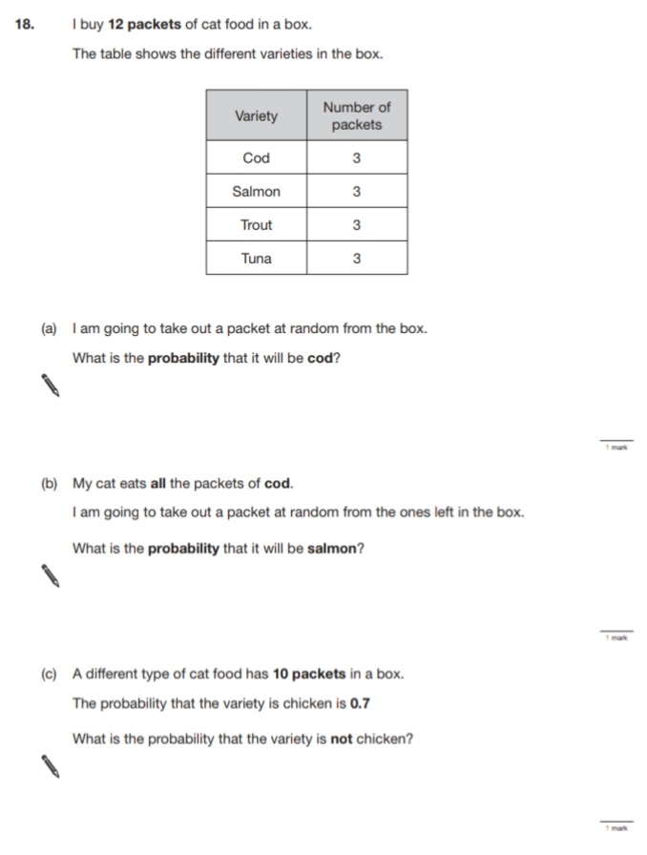
Key Stage 3: 2006 Paper 2 Level 4-6
12.
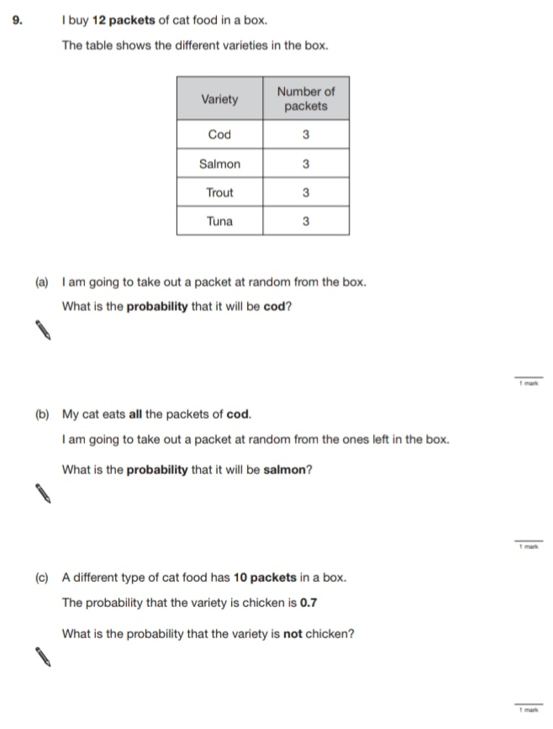
Key Stage 3: 2007 Paper 1 Level 3-5
13.
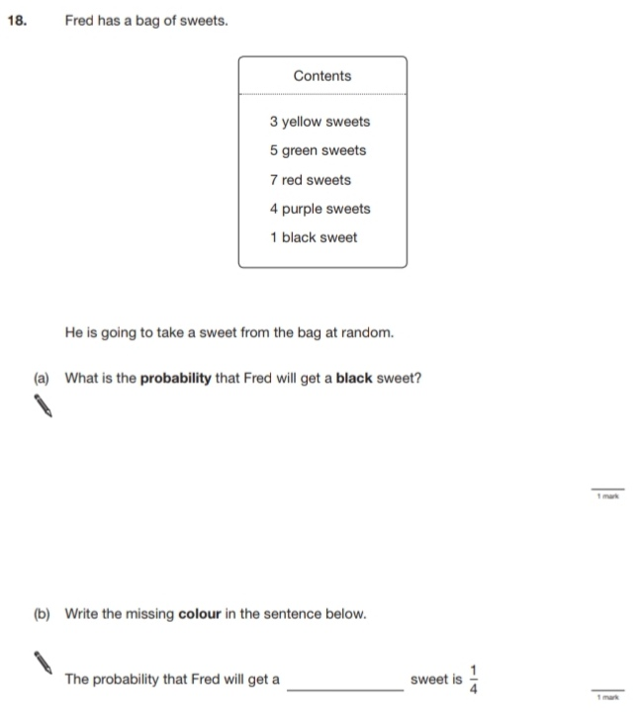
Key Stage 3: 2007 Paper 2 Level 3-5
14.
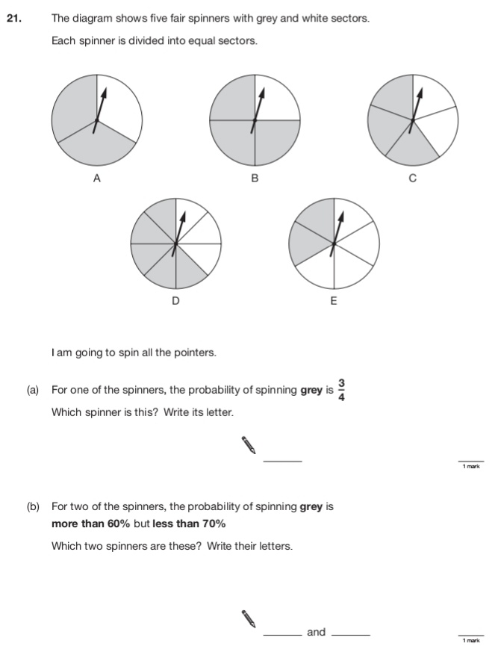
Key Stage 3: 2007 Paper 1 Level 4-6
15.
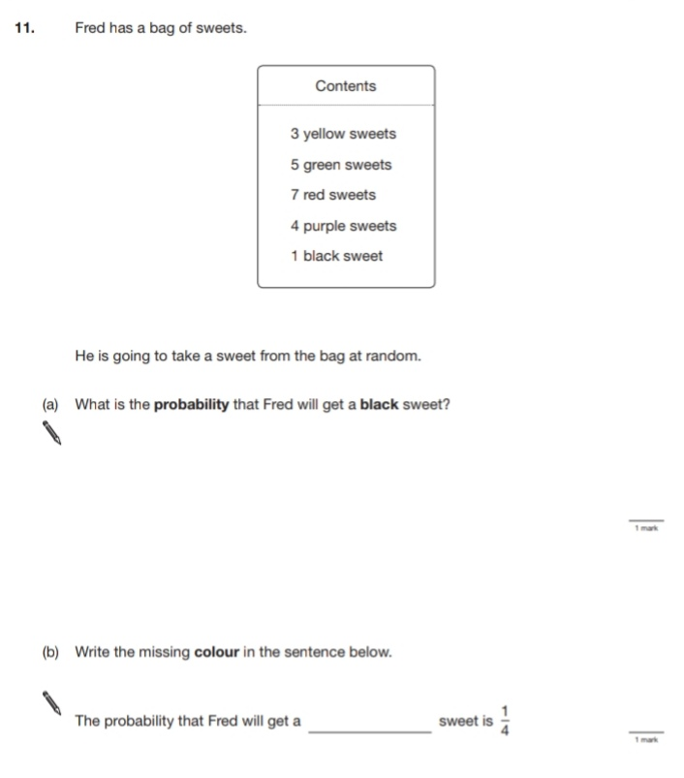
16.
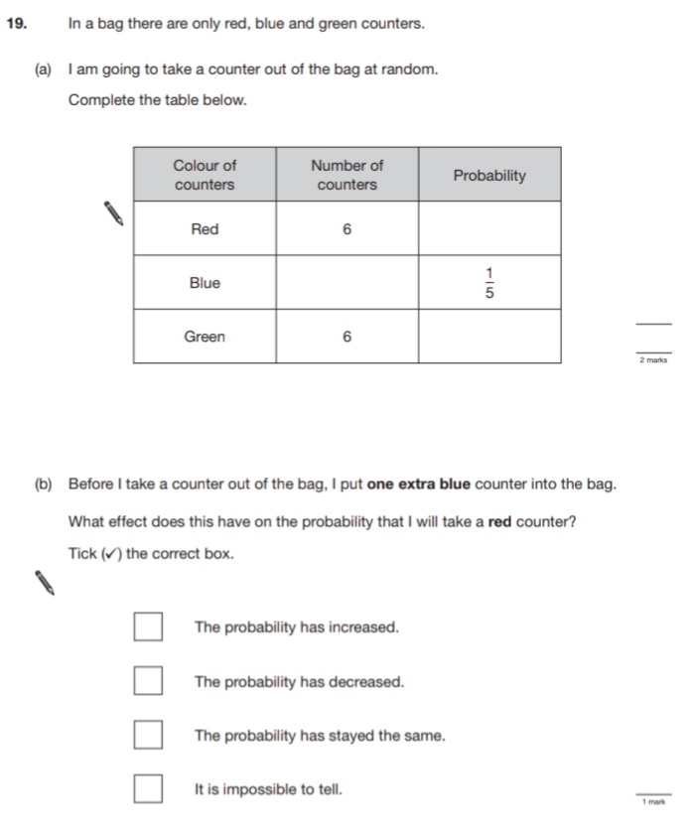
Key Stage 3: 2007 Paper 2 Level 4-6
17.
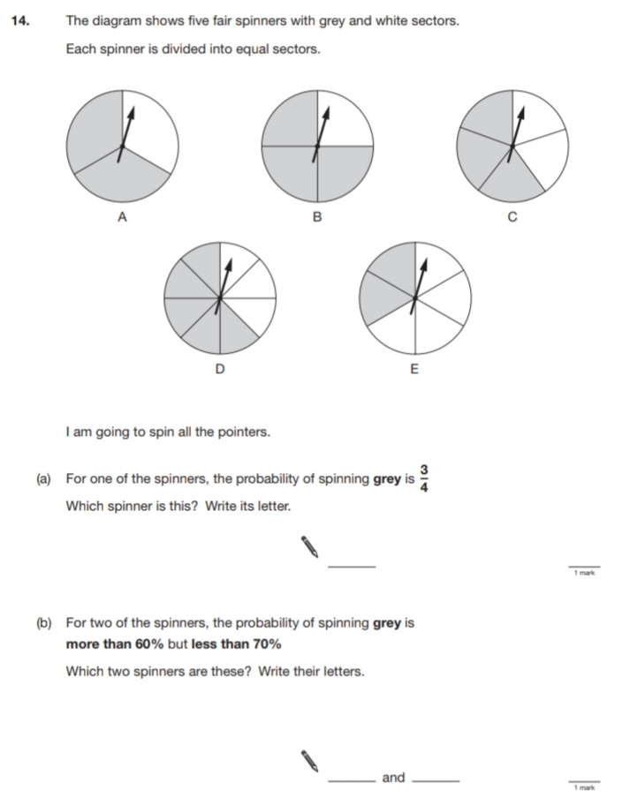
18.
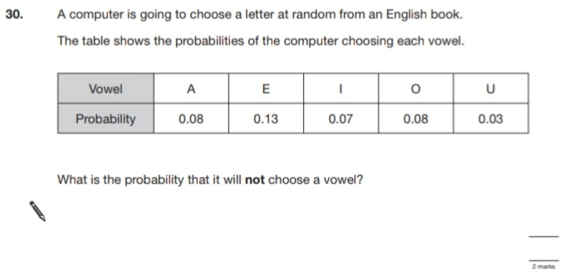
Key Stage 3: 2008 Paper 2 Level 3-5
19.
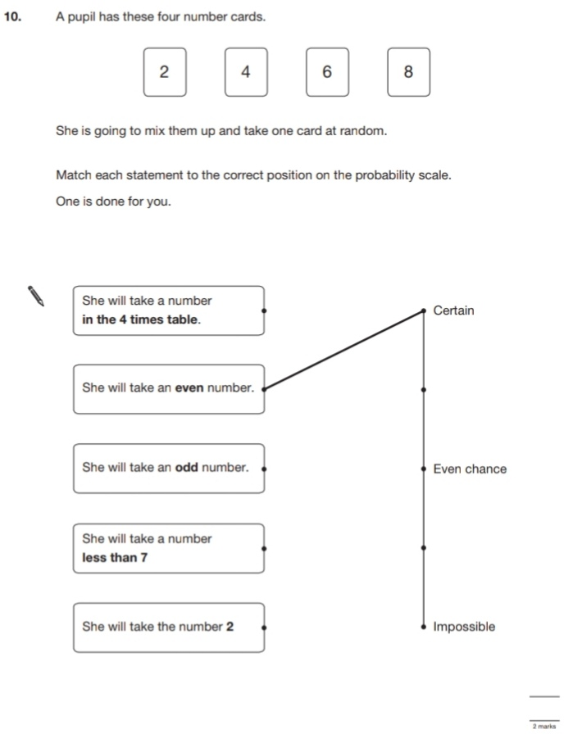
Key Stage 3: 2008 Paper 2 Level 4-6
20.
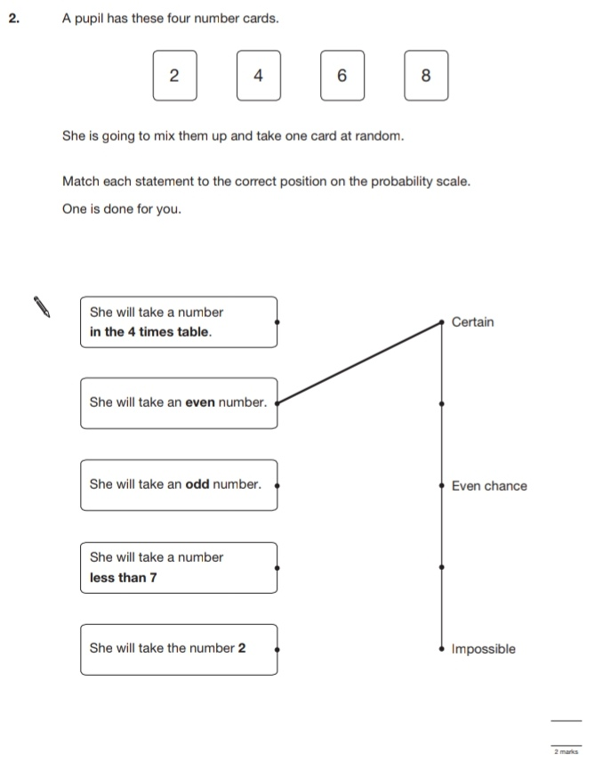
21.
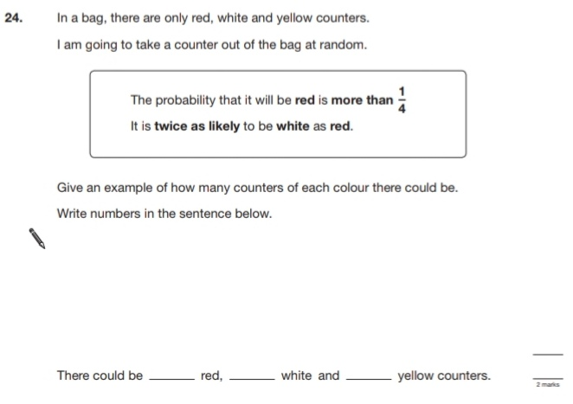
Key Stage 3: 2009 Paper 1 Level 3-5
22.
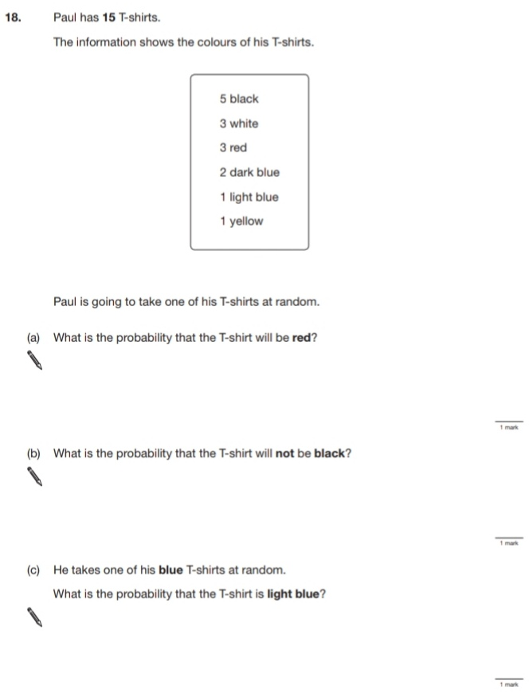
Key Stage 3: 2009 Paper 2 Level 3-5
23.
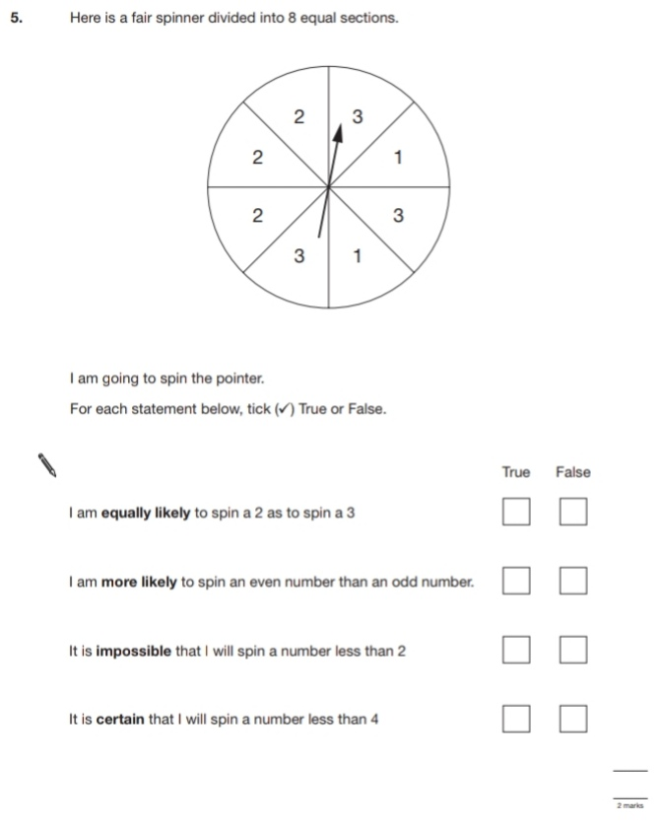
Key Stage 3: 2009 Paper 1 Level 4-6
24.
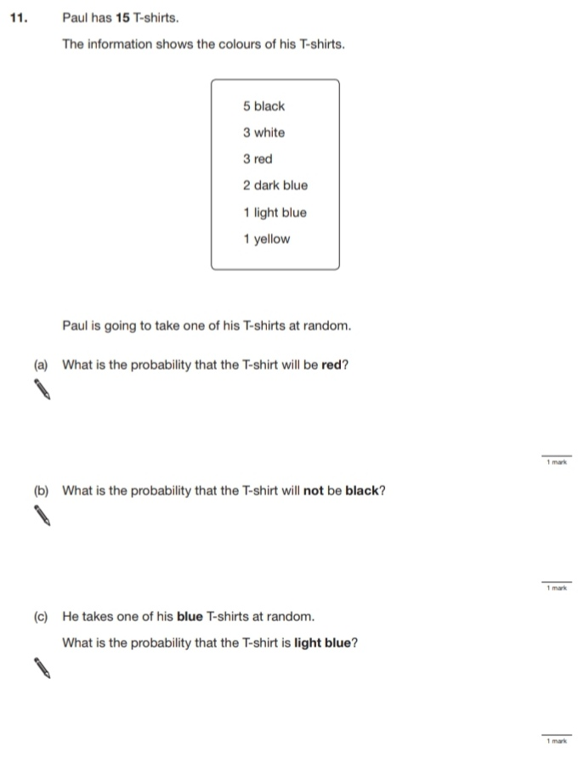
Key Stage 3: 2009 Paper 2 Level 4-6
25.
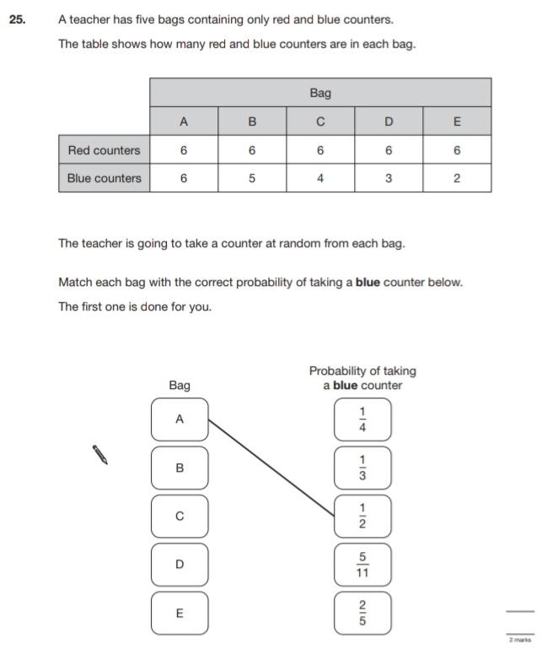
Key Stage 3: 2010 Paper 2 Level 3-5
26.
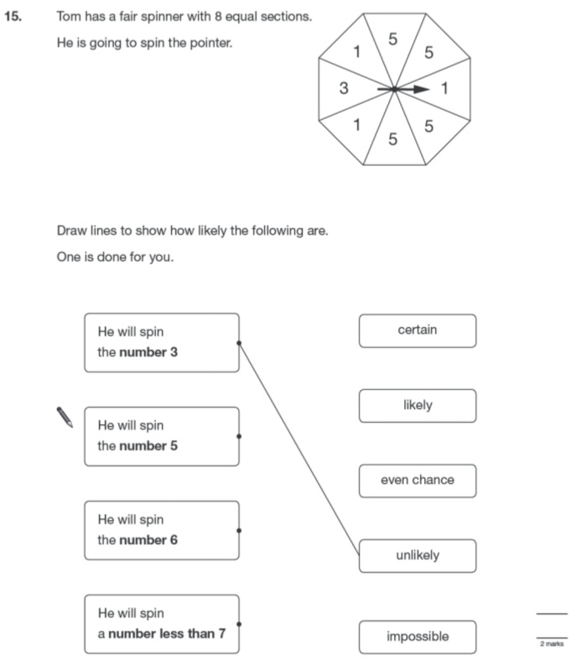
Key Stage 3: 2010 Paper 1 Level 4-6
27.
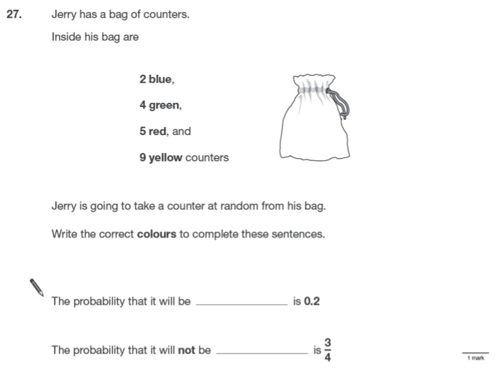
Key Stage 3: 2010 Paper 2 Level 4-6
28.
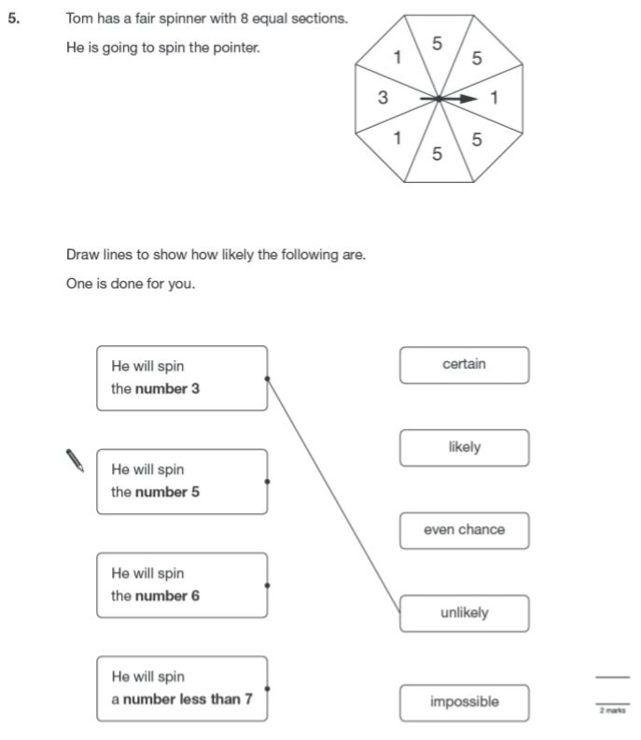
29.
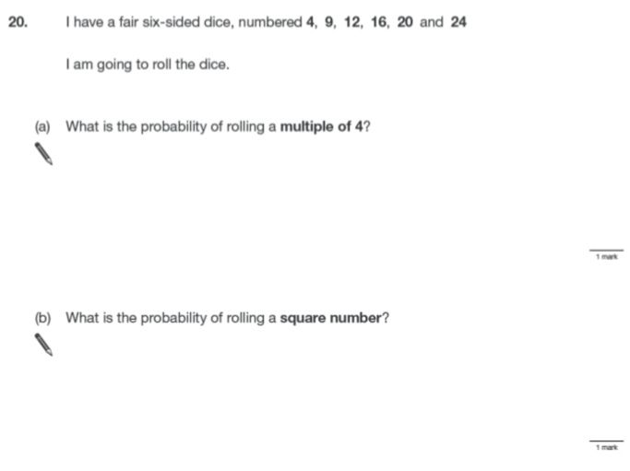
Key Stage 3: 2011 Paper 1 Level 4-6
30.
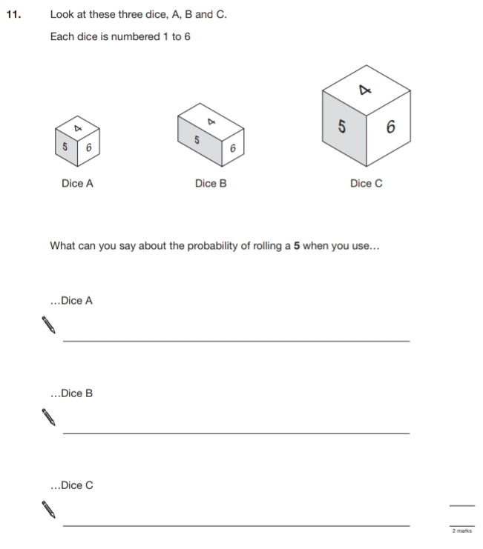
31.
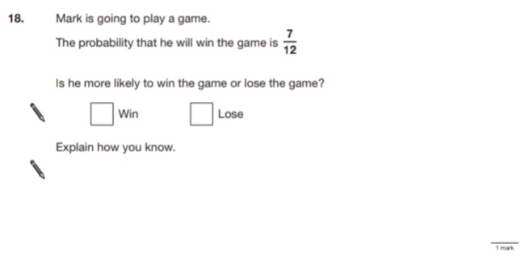
32.
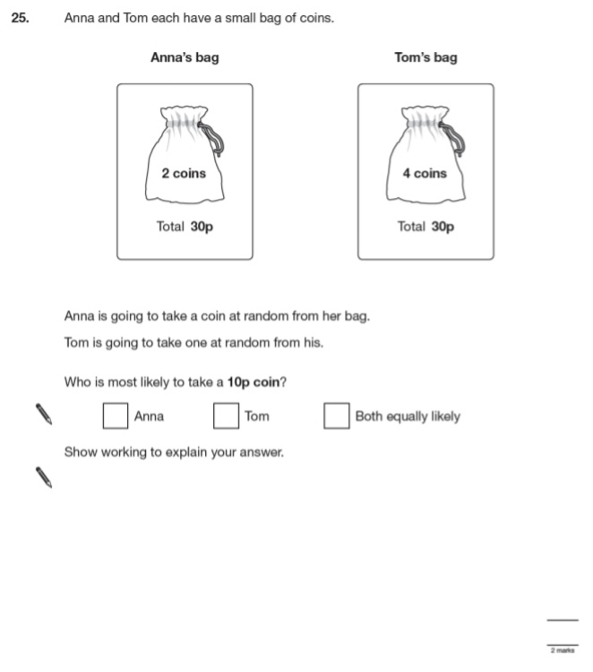
Key Stage 3: 2011 Paper 2 Level 4-6
33.
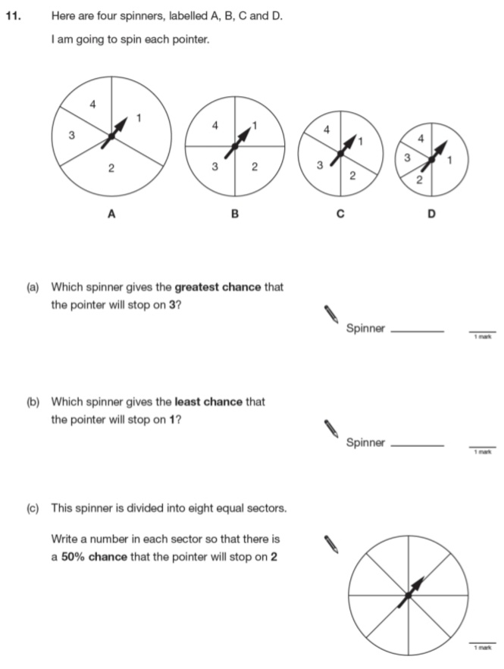
34.
